Twin City Area of NA

Picnic

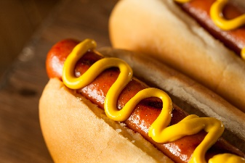0 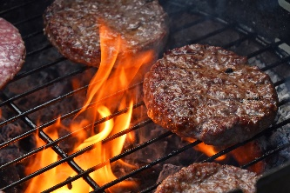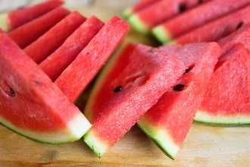

**When: June 1st, 2024**

**Where: Miller Park Shelter #1 – 400 Leisure Lane, WS**

**Homegroups are asked to bring Side Dishes/Drinks/Condiments/Desserts**

**Contact: Andy H. 336/655-8234**

**Schedule of Events:**

**Setup @ 10:00 am Clean up by 5:00 pm (help is requested)**

**Food - Noon – 2:00 pm**

**Speakers begin at 2:00 pm**

FOOD FUN FELLOWSHIP

**Bring a Chair, Games, Cards but please, No Pets**